**Assignment 1**

# Computational Intelligence SEW, SS2017

|  |  |  |
| --- | --- | --- |
| **Team Members** | | |
| Last name | First name | Matriculation Number |
| Guggi | Simon |  |
| Papst | Stefan |  |
| Perkonigg | Michelle | 1430153 |

# Derivation of Regularized Linear Regression

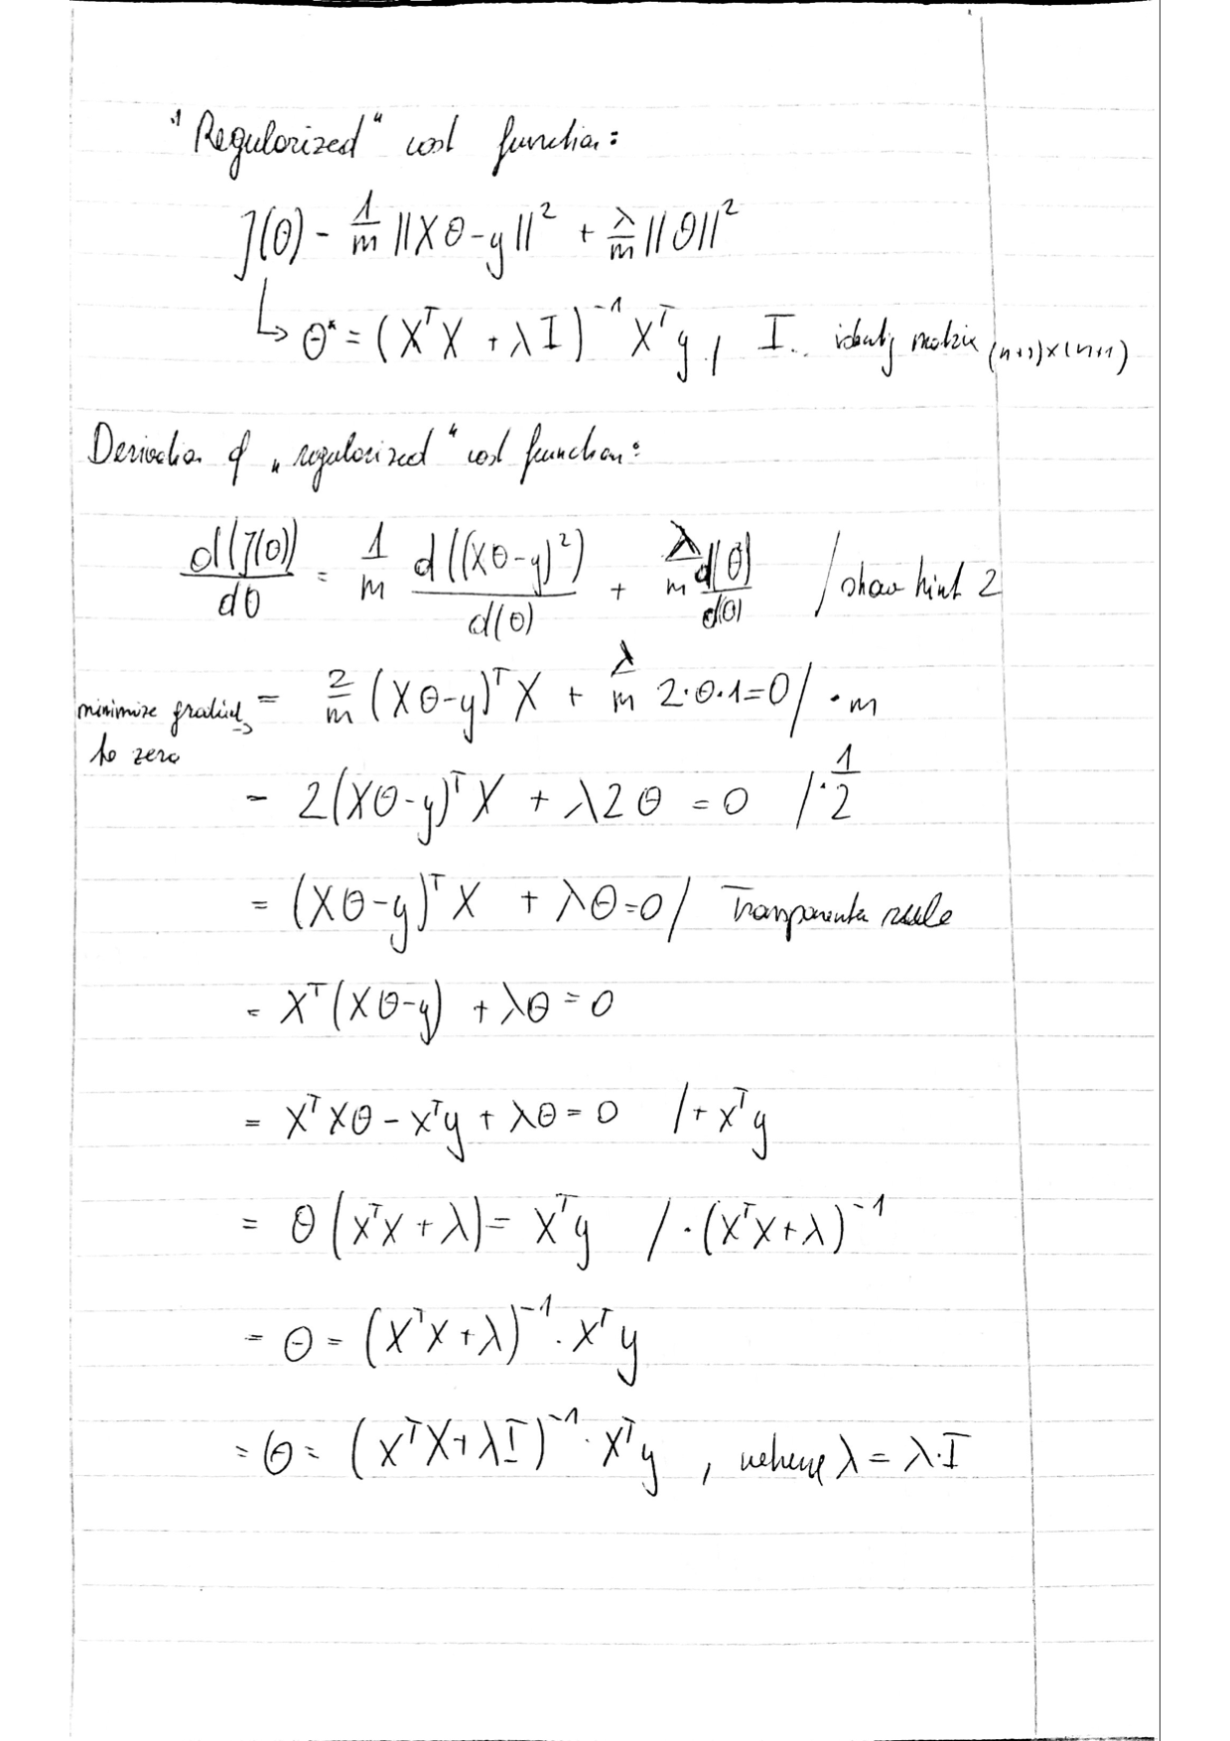

# Plot for each of the following polynomial degrees: 1, 2, 5, 20

### degree 1

### degree 2

### degree 5

degree 20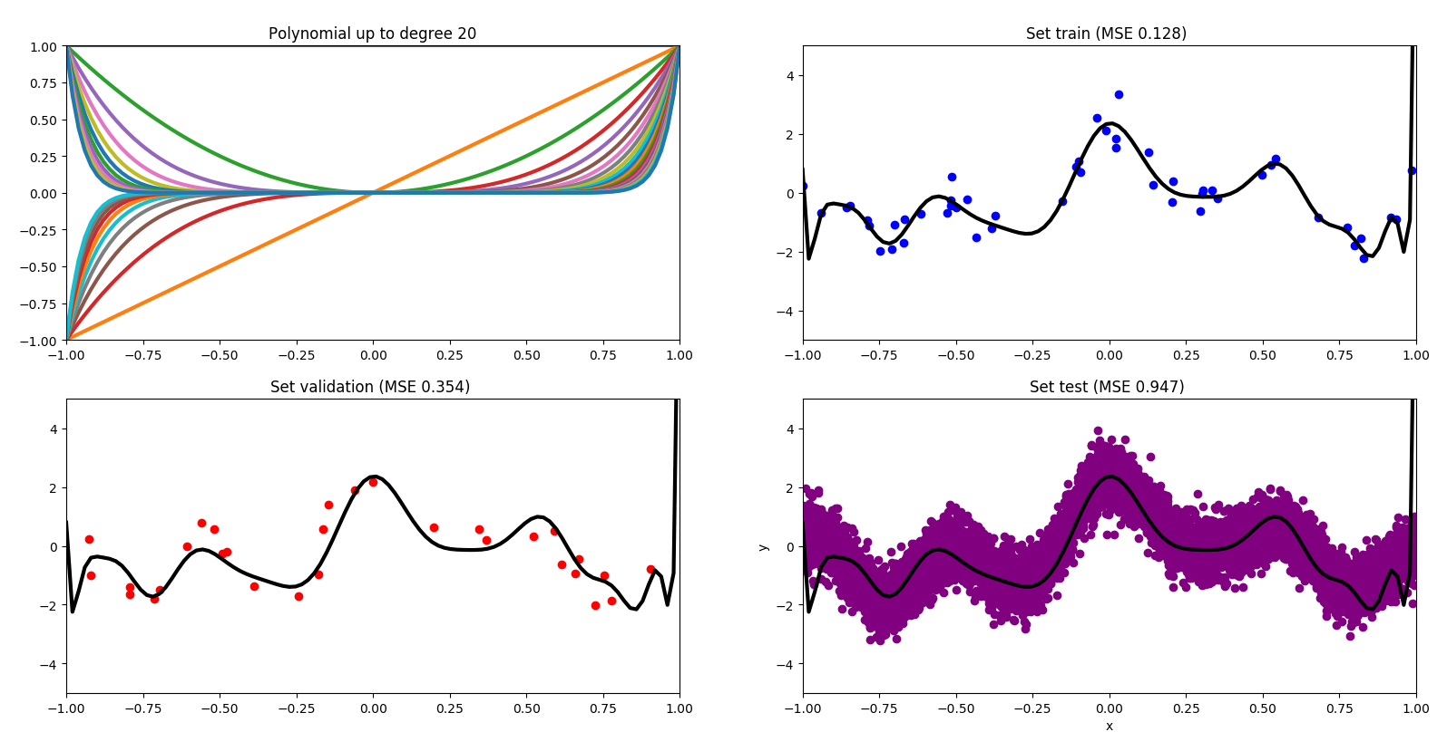

# Plot of polynomial degree with lowest training error

The polynomial degree 30 has the lowest training error.   
Training error: 0.10026711145129742  
Test error: 366141.23594091967

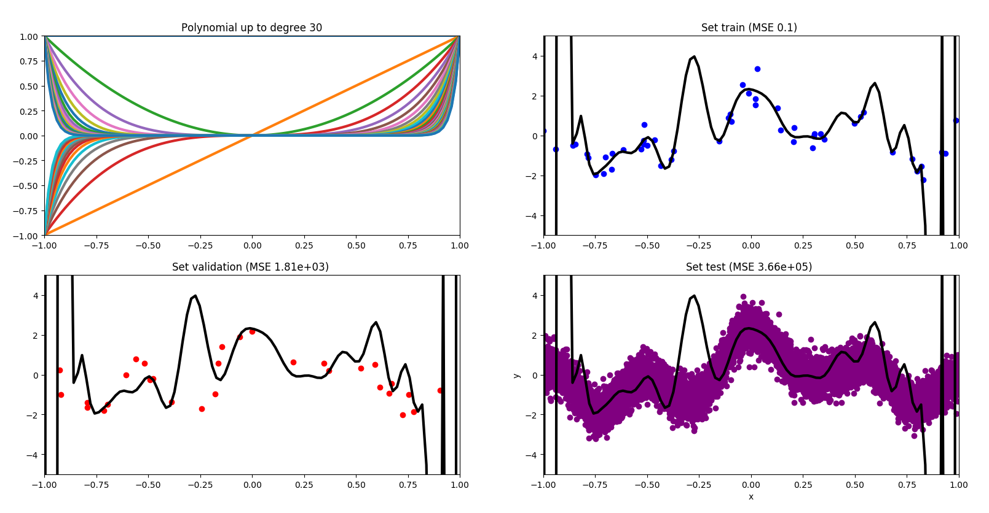

# Plot of polynomial degree with lowest validation error

The polynomial degree 13 has the lowest validation error.   
Validation error: 0.305228632706  
Testing error: 0.3837016046508086

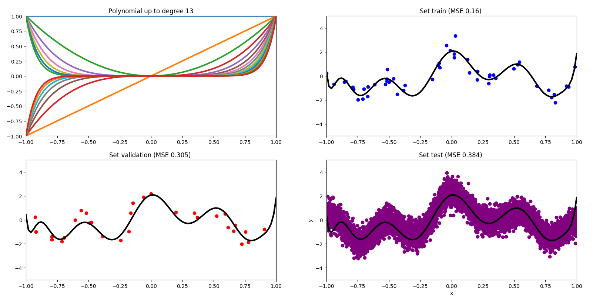

# Plot of training, validation and testing errors as a function

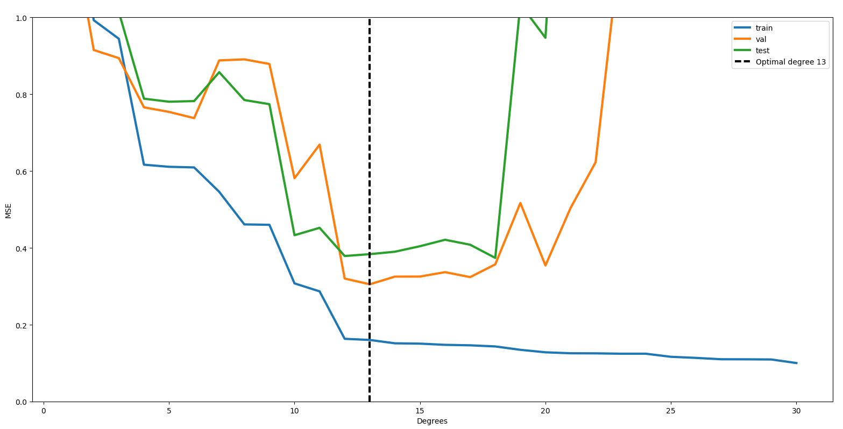

# Discuss your findings in your own words using the concept of over-fitting. Why is it important to use a validation set?

*Overfitting:* When a model is overfitted it is too complex, because of too many parameters. Overfitting leads to a low training error but a very high testing error.

|  |  |  |
| --- | --- | --- |
|  | polynomial degree 13 | polynomial degree 30 |
| training error | 0.1603029754981785 | 0.1002671114512974 |
| validation error | 0.3052286327055114 | 1805.9699422675815 |
| testing error | 0.3837016046508086 | 366141.23594091967 |

The table shows a comparison between a model with the lowest training error and a model with the lowest validation error. As you can see the results differ significantly. While the training error of the polynomial degree 30 is very small, the validation and testing errors are extremely high. This type of model is called as overfitted. The polynomial degree 13 shows a moderate training error, but a very small validation error. The validation set is used to avoid overfitting. The right fitted model is the one with the smallest testing error.  
   
The plot of the training, validation and testing errors as a function shows that the blue line, the training errors have its lowest point at the polynomial degree 30. It seems like the training error functi The orange line, the validation error has its lowest point at the polynomial degree 13 and the green line, the testing errors have its lowest point at the polynomial degree 18.

# Derivation of Gradient

# 2.png

# Plot for each of the following degrees: 1, 2, 5, 20

### degree 1

### degree 2

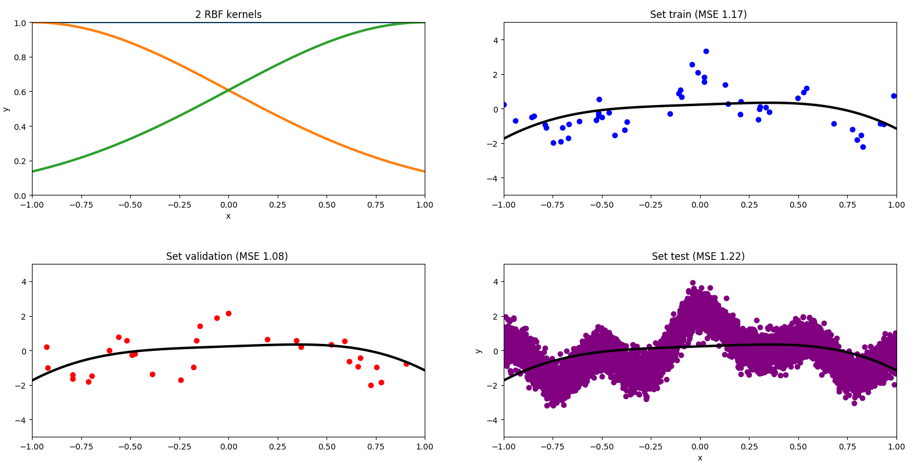

### degree 5

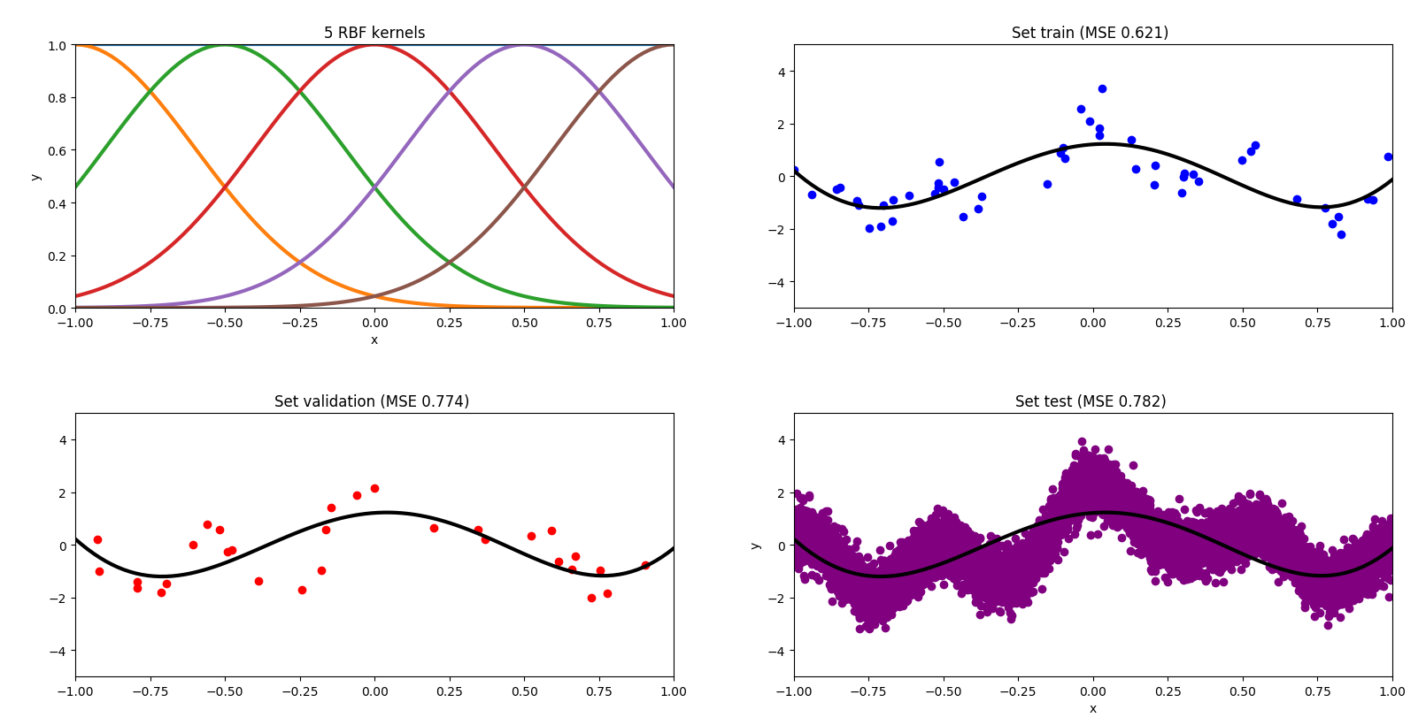

### degree 20

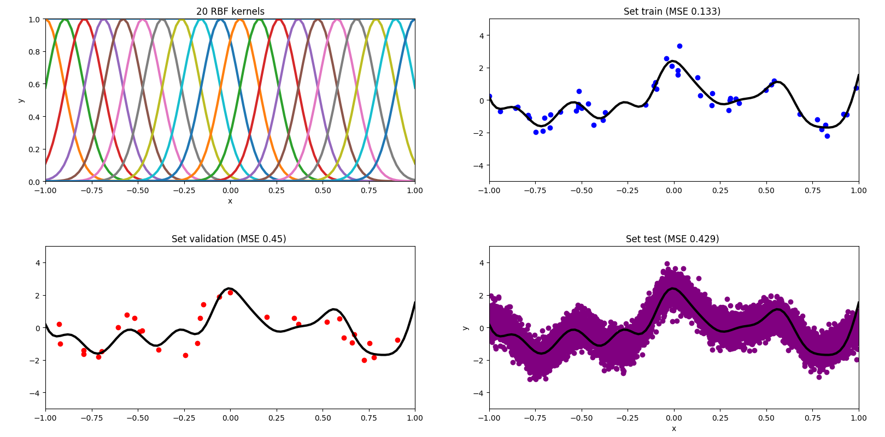

# Plot of RBF with lowest training error

The RBF 40 has the lowest training error.   
Training error: 0.054452916301051674  
Testing error: 181.67182614369543

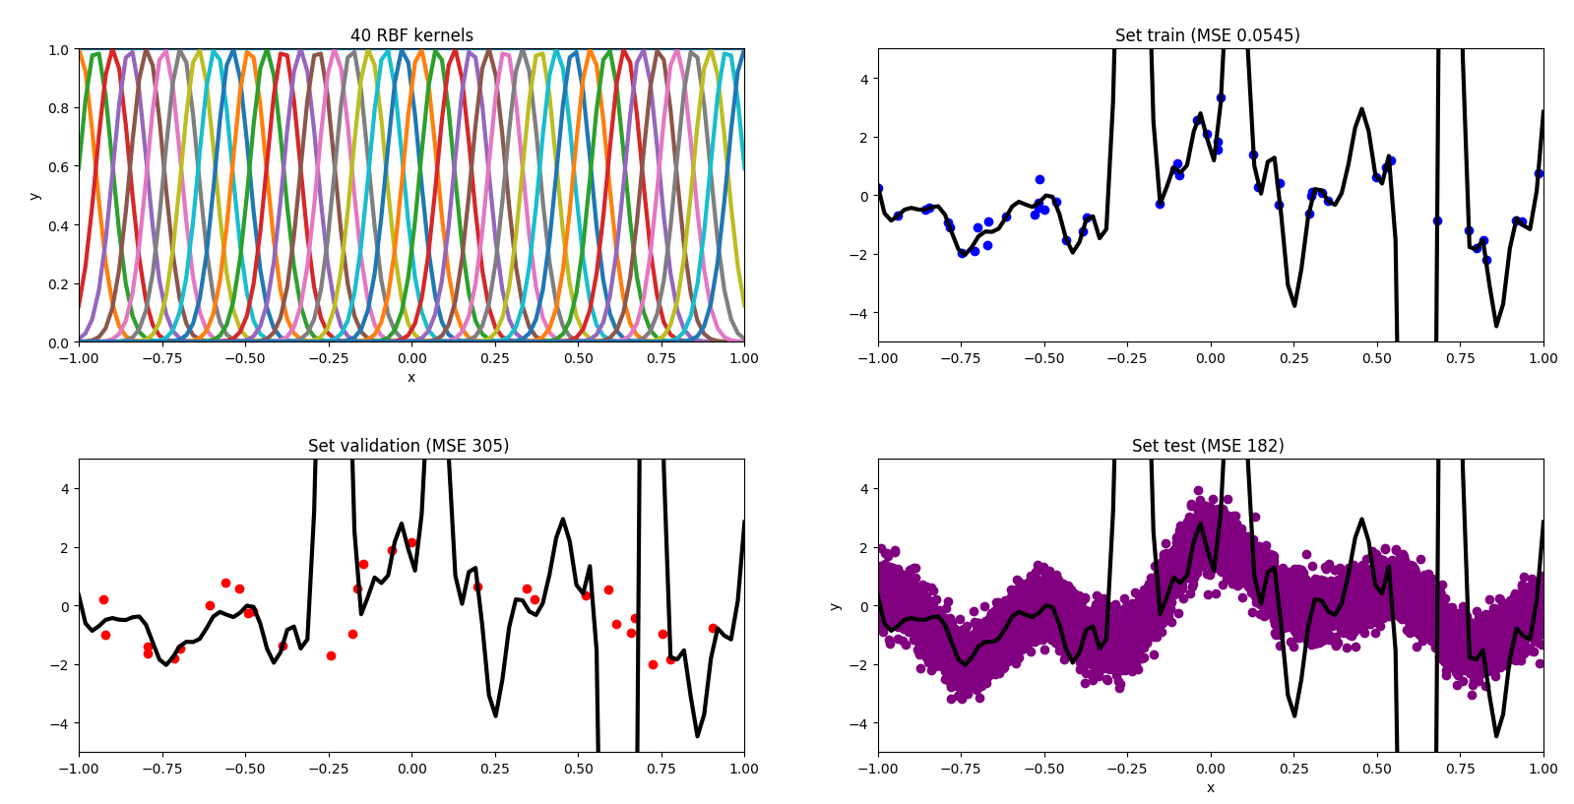

# Plot of RBF with lowest validation error

The RBF 9 has the lowest validation error.   
Validation error: 0.2879598418721303  
Testing error: 0.3370130082408977

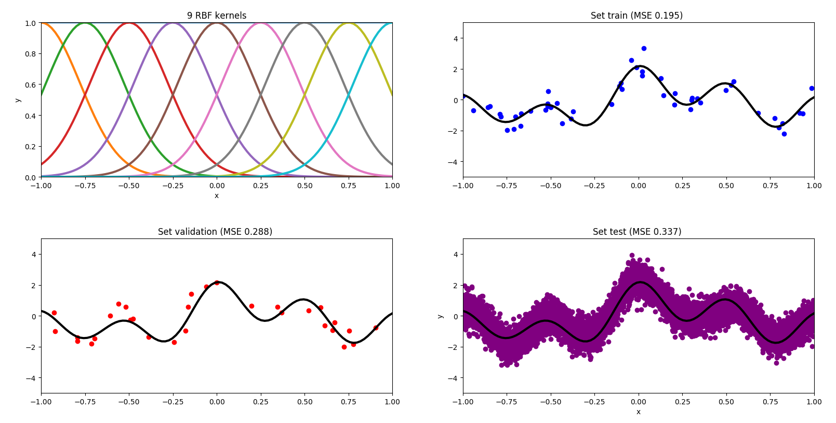

# Plot of training, validation and testing errors as a function

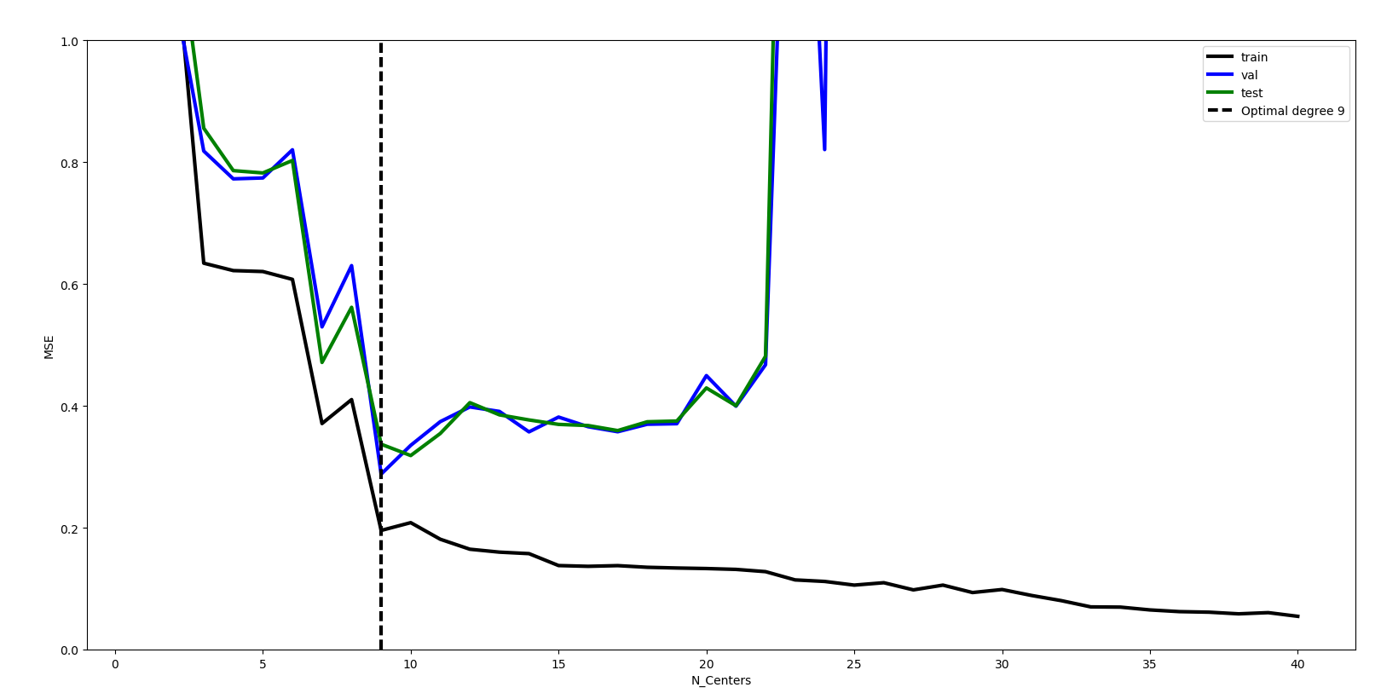

# Briefly describe and discuss your findings in your own words.

The RBF with the lowest training error is, as with the polynomial model, the highest degree tested (degree 40). The testing error is again very high and therefore the RBF is overfitted. The lowest validation error achieved the RBF with degree 9. This one has a significant lower testing error than the RBF with degree 40. In this case the RBF model with the lowest validation error has the same degree as the RBF model with the lowest testing error. Both have degree 9, as you can see in the plot of training, validation and testing errors as a function. The black line represents the training errors, the blue line the validation errors and the green line the testing errors.

Is the polynomial or the RBF model better?

The RBF model is better.

# The function check_gradient in toolbox.py is here to test if your gradient is well computed. Explain what it is doing.

The function checks if the calculated gradients are well computed by finite difference approximation. The finite difference approximation is calculated on the following basis: $$\frac{\left(f\left(x+eta*dx\right)-f\left(x\right)\right)}{eta} converges toward grad*dx$$

# For degree l = 1 run GD for 20 and 2000 iterations (learning rate *ƞ* = 1, all three parameters initialized at zero). Report training and test errors for each iteration number and plot the decision boundaries. Comment on the results and explain why the number of iterations should be neither too low nor too high.

degree: 1  
eta: 1  
iterations: 20

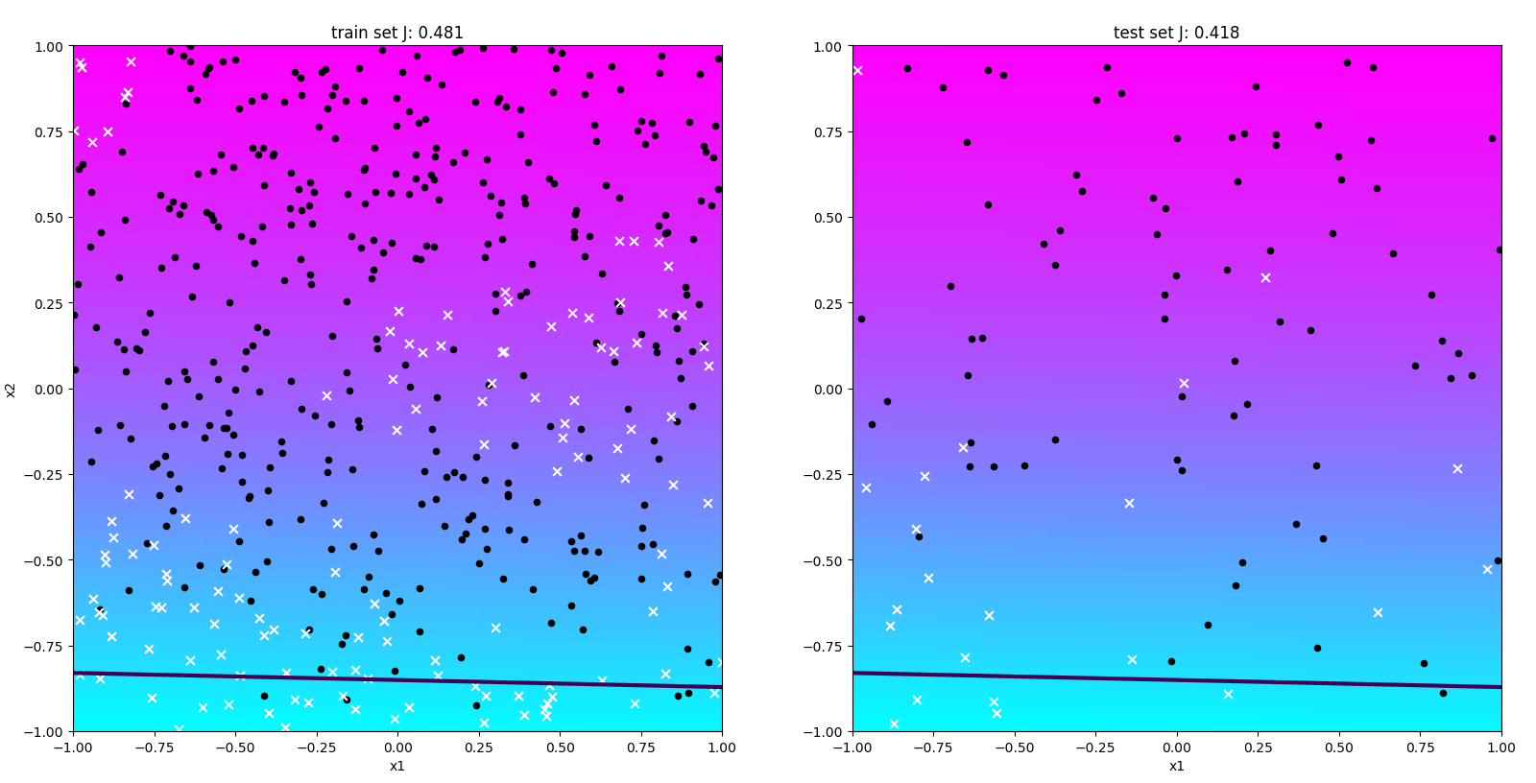

degree: 1  
eta: 1  
iterations: 2000

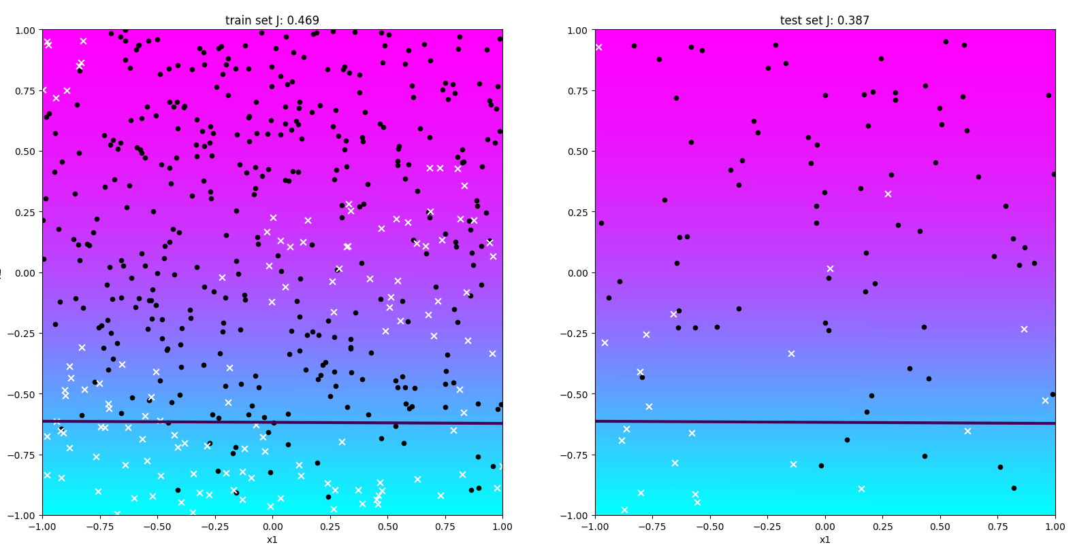

# For degree l = 2 run GD for 200 iterations and learning rates of *ƞ* = .15, *ƞ* = 1.5 and *ƞ* = 15.. Report training and test errors for each iteration number and plot the decision boundaries. Comment on the results and explain what is happening when *ƞ* is too large or too small.

degree = 2  
eta = .15  
iterations = 200

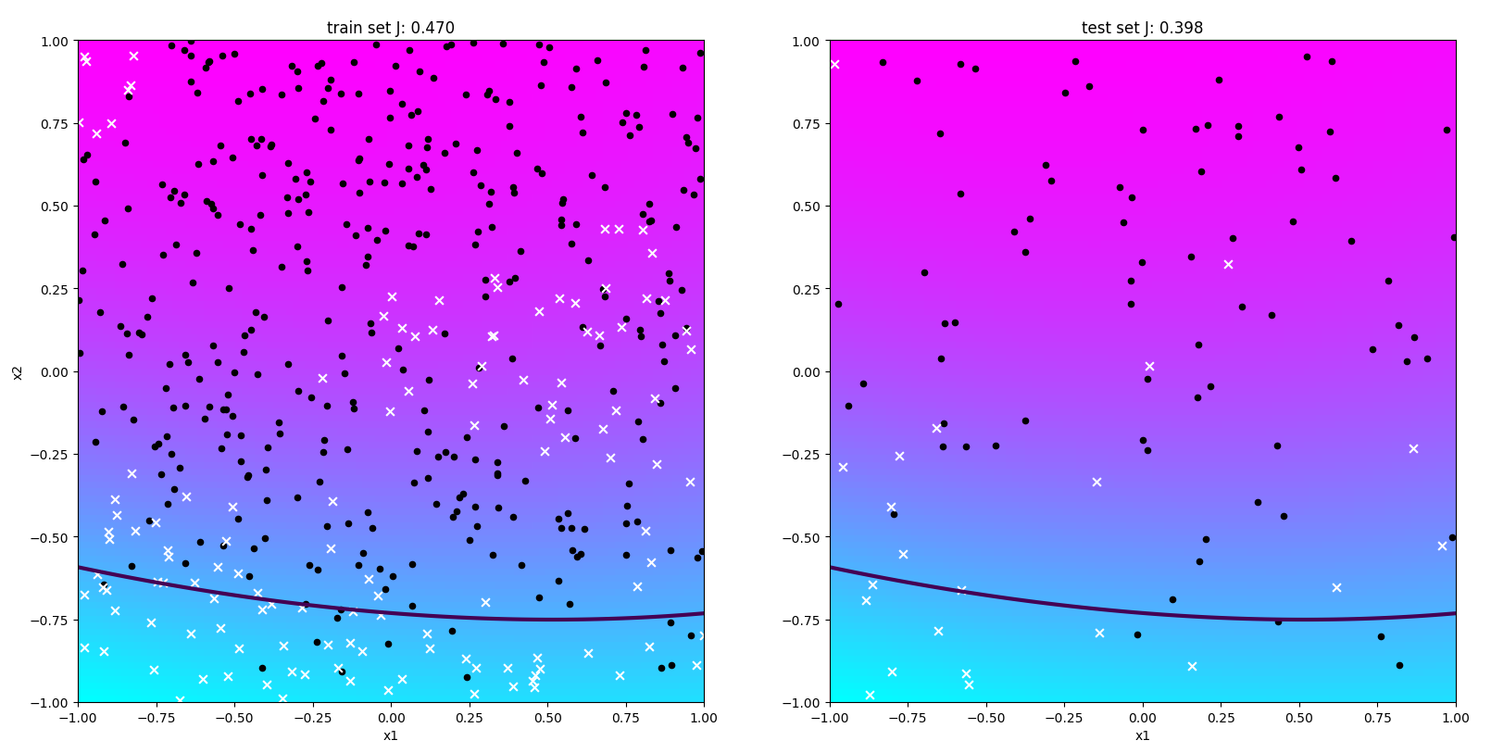

degree = 2  
eta = 1.5  
iterations = 200

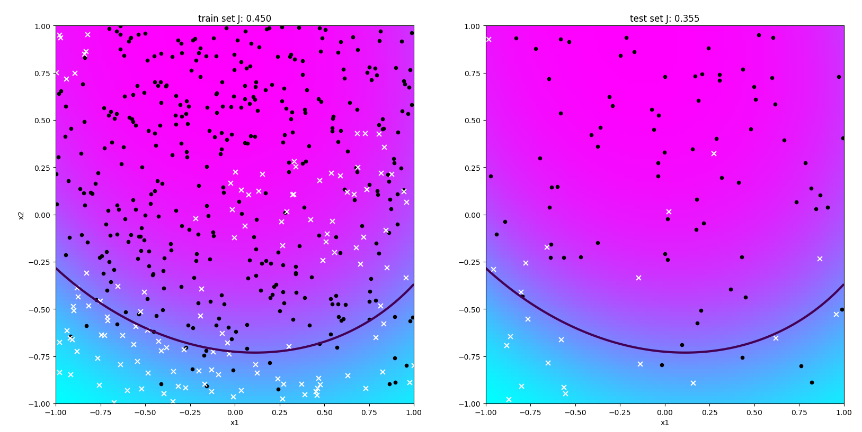

degree = 2  
eta = 15.  
iterations = 200

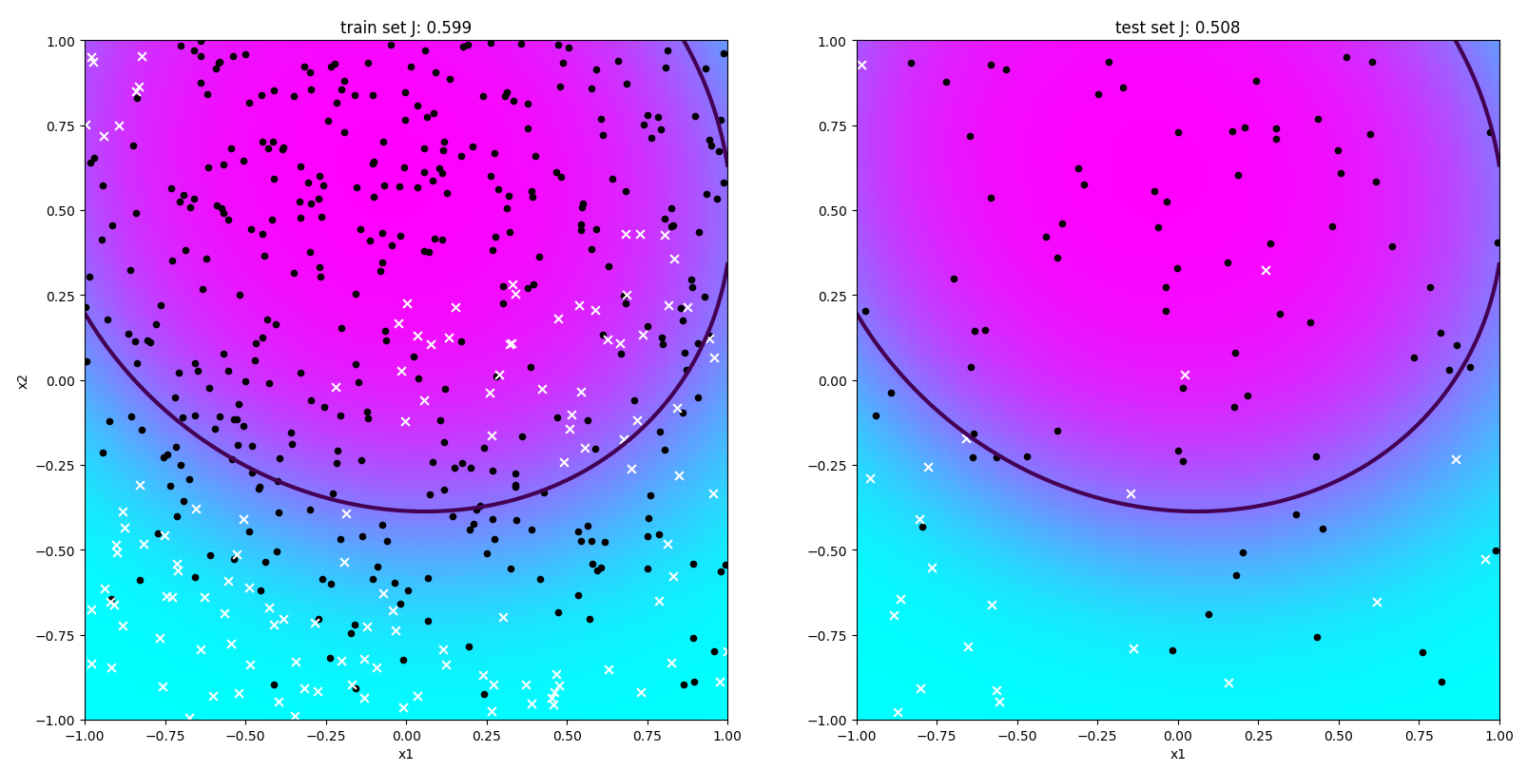

# Identify reasonably good pair of values for the number of iterations and learning rate for each degree in l є {1, 2, 5, 15} that provides a good solution in reasonable time. Report these pairs, the performance obtained on training and testing set and plot each solution. Conclude by describing which degree seems the most appropriate to fit the given data.

# Stopping criterium to avoid doing too many iterations

Early Stopping is a method to avoid overfitting. After every iteration, the performance is evaluated on the testing set. Up to a certain point the performance of the training set is improved but after this point the performance decreases.

Run GDad for varying degrees l є {1, 2, 5, 15} (with zero initialization of parameters, 1000 iterations, and initial learning rate *ƞ* = 1). Report training and test errors, final learning rates and plot the

hypothesis obtained in each case with function plot_logreg in file logreg_toolbox.py.

degree: 1

final learning rate: 0.385 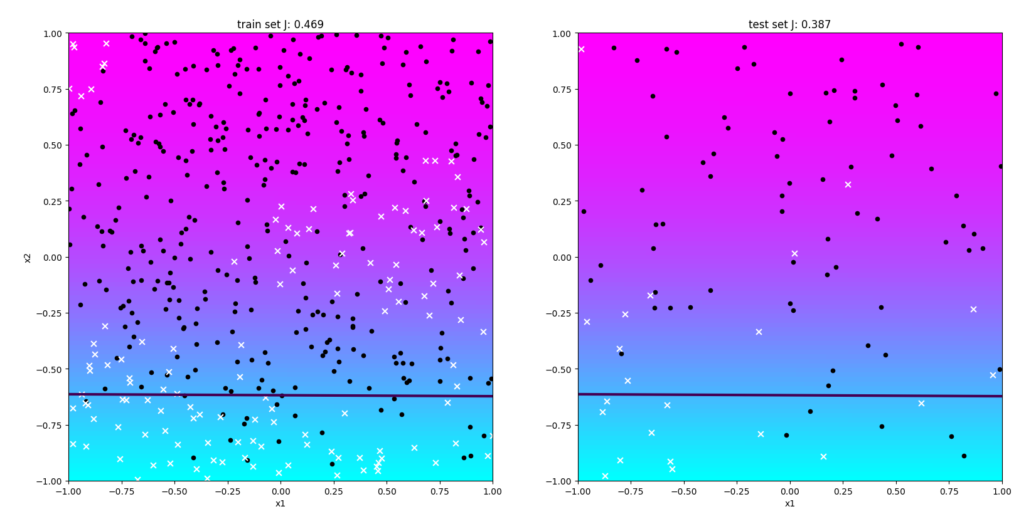

degree: 2

final learning rate: 5.11e-08

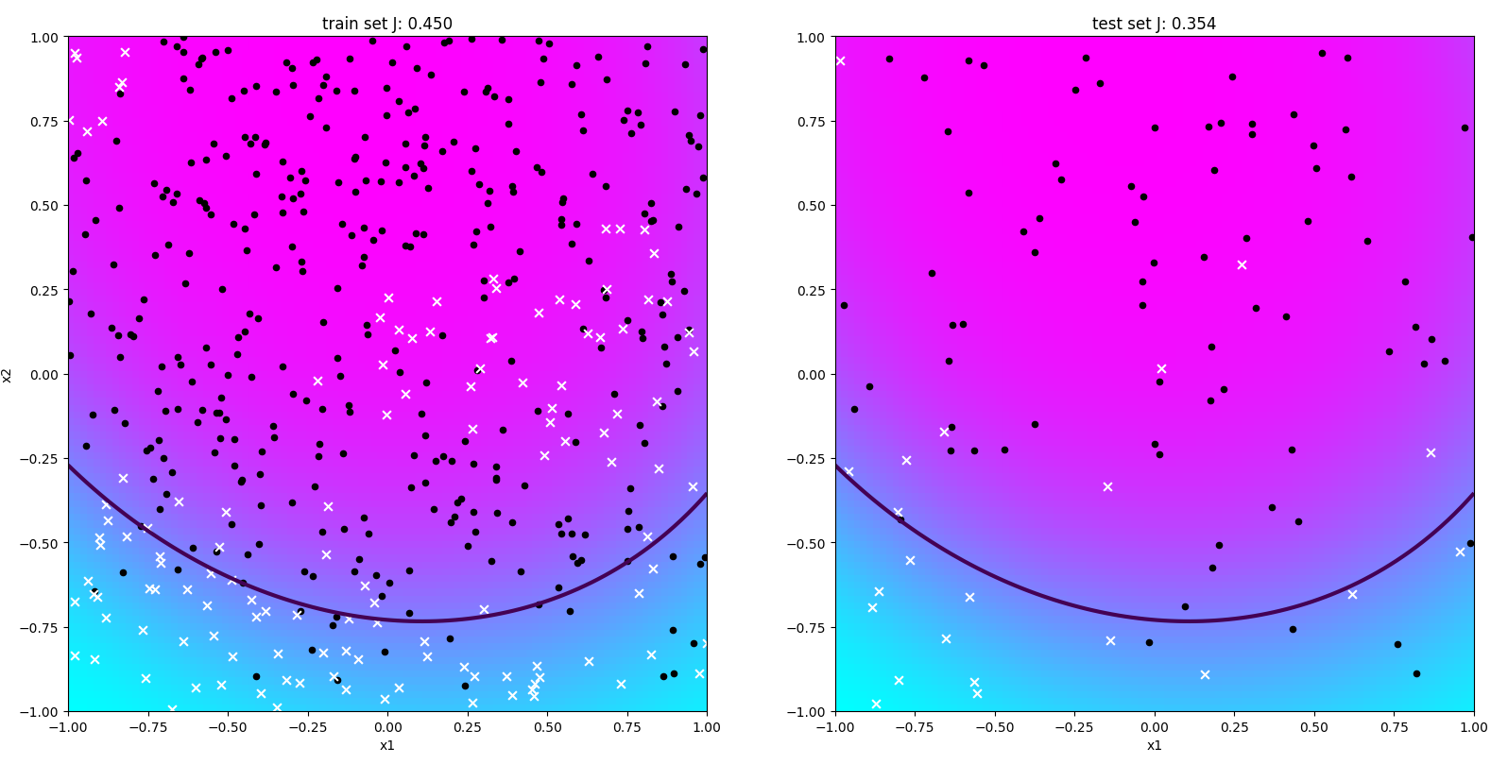

degree: 5

final learning rate: 12.5

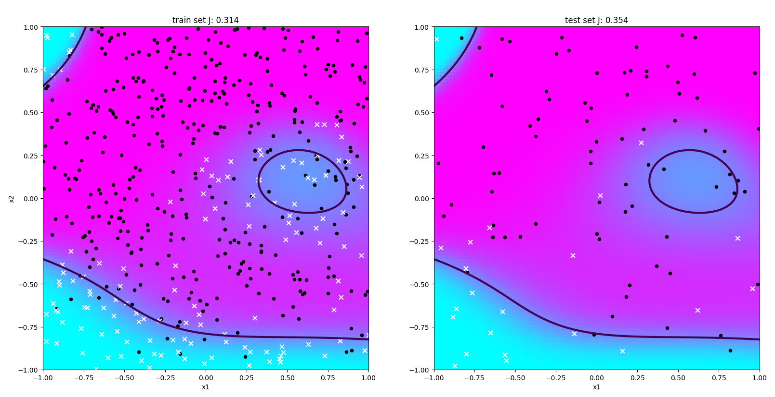

degree: 15

final learning rate: 12.5

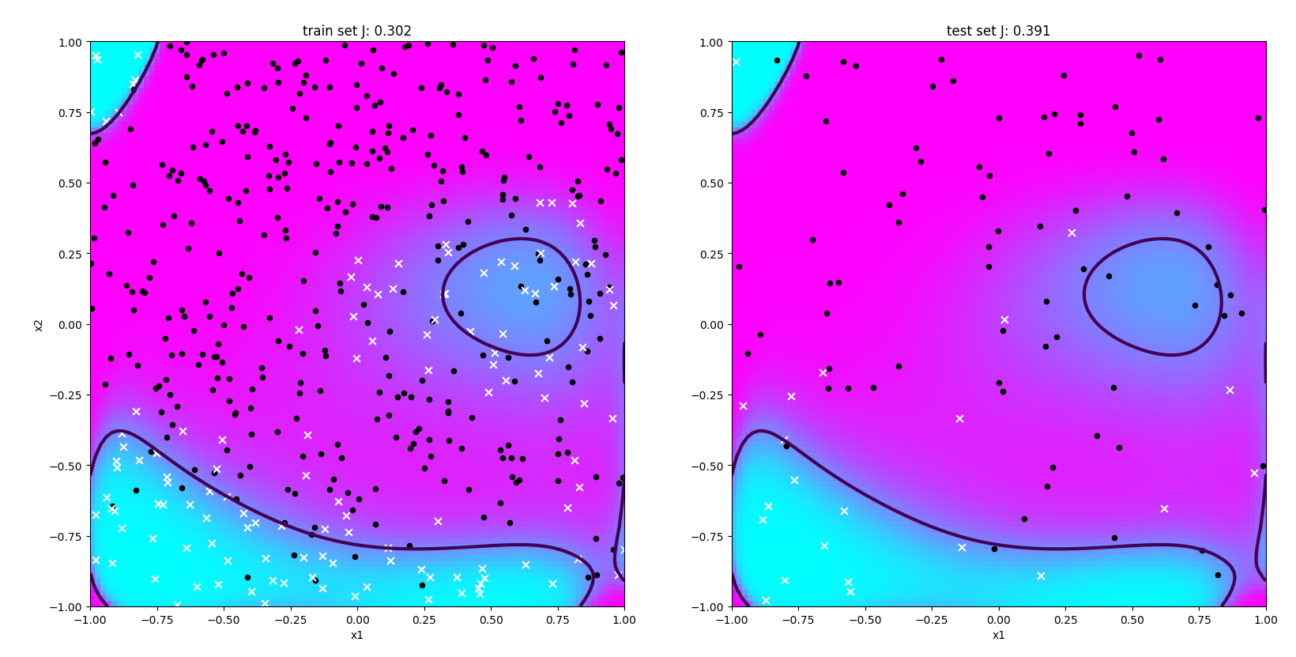

For each degree compare with the non-adaptive gradient descent variant. In particular, is the final learning rate numerically coherent with your previous guess? Discuss why GDad can be useful.